**SPECIFICATION FOR THE DEVELOPMENT OF A MOBILE APPLICATION FOR NIGERIAN YOUTH CORPERS**

**Introduction**

The mobile application is software that will be used by NYSC members (community of friends) to facilitate communication and the exchange of information and files over the internet with the use of mobile accessories like: tablet, Smartphone, notepad etc. The software is intended for two classes of people:

1. The Nigerian Youth Corps (graduate students from the University; home and abroad) and
2. The administrative arm of the NYSC.

The Youth Corps (graduate students) who have been deployed for Youth services in states across the Federation (Federal Republic of Nigeria, FGN) at their respective state of deployment for the one (1) year Youth Service programme may use the software to perform various activities like: collaboration and social-networking services, location services, notification services etc while the administrative arm of the NYSC can also use the software to pass important information to the Youth Corps community.

The application shall be called **KỢPA WEE.**

**Services**

The software will initially be developed for the android platform while subsequent versions will be available to support the Blackberry OS, iOS, Java ME etc. The basic services which the application will be able to perform include but not limited to the following:

1. Unlimited users registration and authentication;
2. Synchronization with other social networking platforms (Facebook, Google+, Twitter, Instagram etc);
3. Status updates and Notification on Social networks like Facebook, Google+, Twitter, Instagram etc;
4. Media upload (files, pictures, audio, video etc);
5. News and Articles Feeds (RSS);
6. Maps and Geo-location features (frequent places, directions etc);
7. Push Notifications;
8. File (audio, video, pictures, pdf etc) sharing facilities;
9. E-books gallery;
10. Barcode and QR code reader etc

**Basic Requirements**

It is important to discuss the basic information which the system will be requiring for proper functionality and to be able to guarantee authentication and verification. The basic information required is the information containing the details of the valid users of the system, which includes the following:

1. Full Names (Surname first);
2. Call-up number;
3. Batch set;
4. State of deployment; and
5. Contact Number-provided during registration at the camp (this will be used to send a verification code to the valid user for authentication subject to verification by the user on the first log into the system in order to complete the registration process alongside the call-up number).

This is the information required by the administrator to create a default register of valid users which will be verified at the point of user registration on the system. Additional information will be used in creating a profile for the user.

**Additional requirements for registration**

On the first access by the user to the system-the verification code (sent by sms to the user by administrator) and call-up number are provided in order to activate the user on the system. The activation is followed by the completion of registration by the provision of the following information:

1. Username;
2. New password;
3. Request for re-deployment (including likely state of deployment);
4. Profile picture (optional at registration but compulsory after registration).

After completing the registration – the user may be able to perform the necessary activities which he/she wants to do. The user can send requests to other users available and activated on the system’s database in order to create his/her contact list or group information etc.

The following documentation gives a break-down of the functionality of the system in terms of the Graphical User Interface (GUI) of the software.

1. **The software Home screen**

The software’s home screen is the first page viewed by the user at the point of first use (see Figure 1 below) – the screen can be accessed by two different classes of users:

1. The first time user which needs to be activated; and
2. The regular user who has been activated.

At first attempt the user is expected to sign up in order to be activated for use of the application (see Figure 2 below), after filling the form in figure 2 the profile of the user is created with a confirmation sent by sms after which the user may use the password (created during activation) alongside with the call-up number to log into the system for every use. After the user logs into the system – he/she may now move to the welcome screen where the different activities may be chosen.

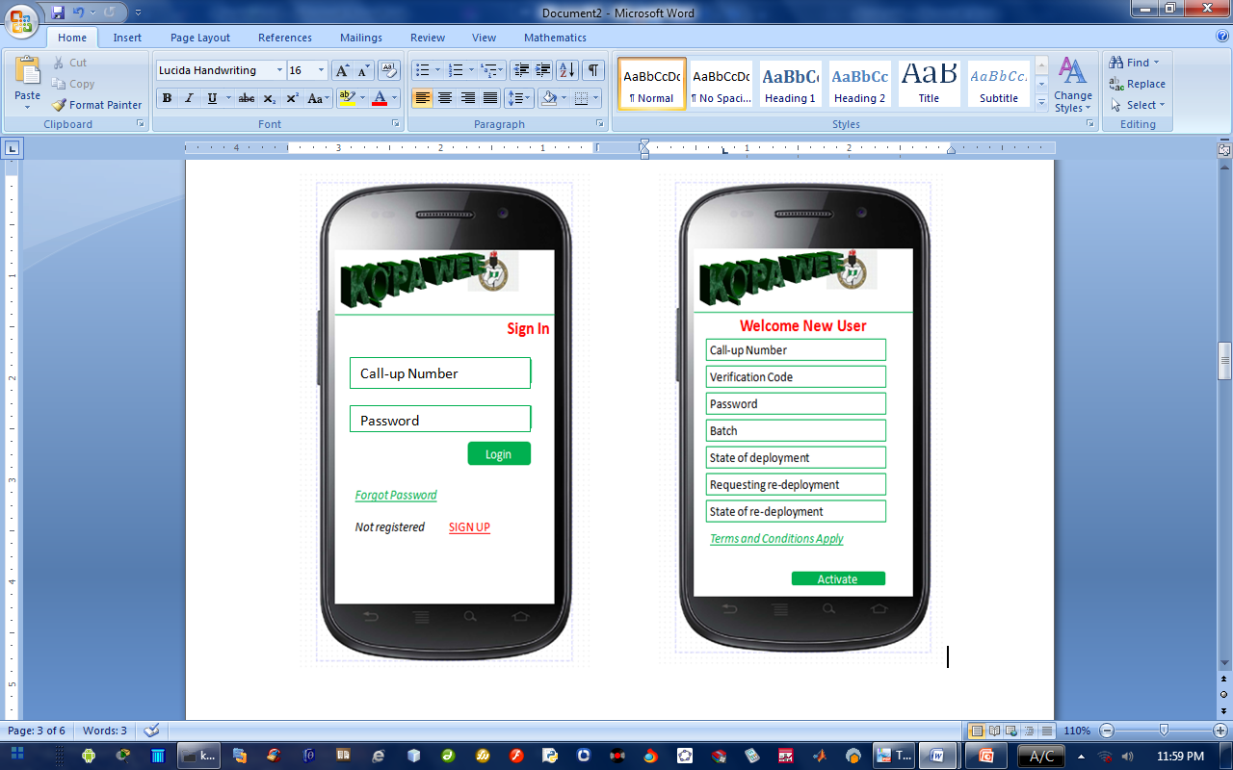

**Figure 1 The home screen of application Figure 2 The activation screen of application**

1. **The Welcome Screen:**

The welcome screen (See Figure 3) is the first active screen which a user accesses at the point of log in to the system; the welcome screen gives the user access to five different activities, which are as follows:

1. Community: which allows the user to communicated with other users via the chat room where groups can be created, broadcasts sent to other contacts, display picture and personal message may also be updated etc;
2. News and Articles: at this area RSS feeds of news and articles may also be uploaded onto the system-which can be either manual or automatic or both;
3. Media Gallery: at this area, the user may upload any type of media like: photos, videos; files (pdf, docx, ppt, xlsx etc) also the system may also be synchronized with other available social platforms in order for any updates performed on the application to be notified on the other popular social platforms;
4. Maps: at this area the user may access his/her own location and at the same time be able to access the location or popular places where other fellow youth corps members may be located in the same city; and
5. Announcements: at this area the administrator may be able to update the users on up-coming events or information important to the general youth corps community
6. **The Community:**

The community serves as the most active spot of the system where the user is able to perform most of his/her activities on the system like uploading profile pictures, display name and updating status. The user is also able to chat (Figure 4) with other members of the community already added to the contact lists (Figure 5).

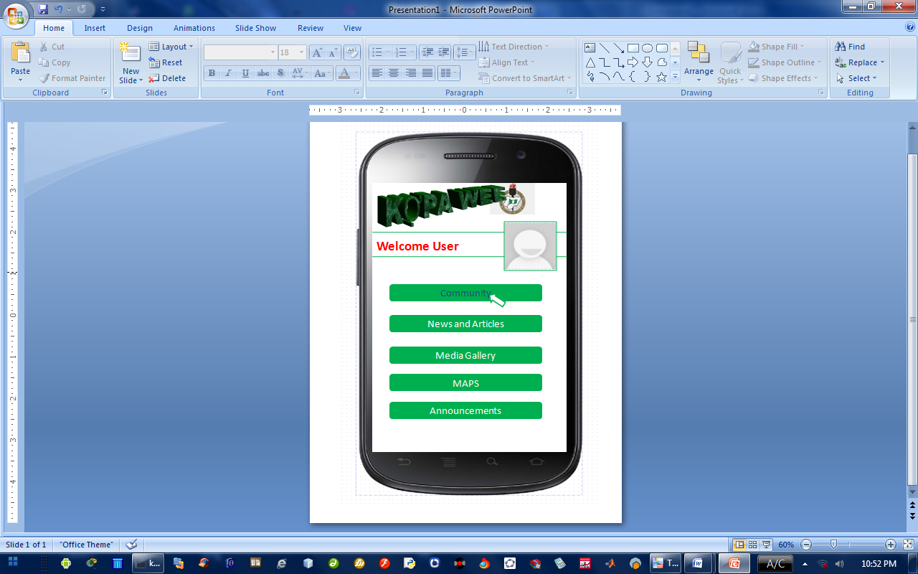

**Figure 3 Welcome Screen of the application**

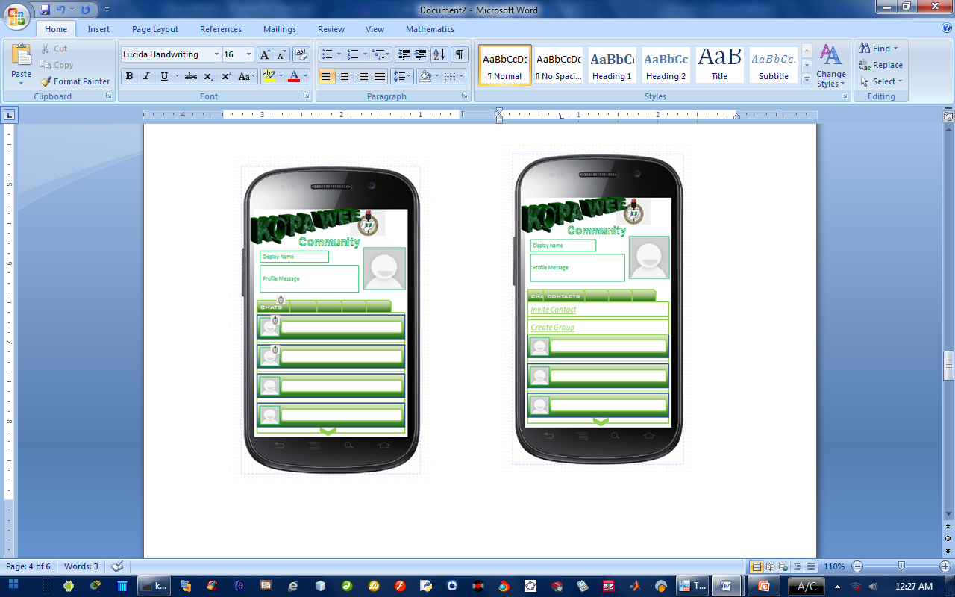

**Figure 4 Community showing chats Figure 5 Community showing contacts and invitation**

1. **Media Gallery**

The media gallery allows the user to upload all types of media into the application which includes: pictures, videos and document files. The application may also be synchronized with other popular social applications in order to allow any uploads or notifications made on the application to be noticed on the social applications that have been synchronized with the application (see Figures 6 and 7).

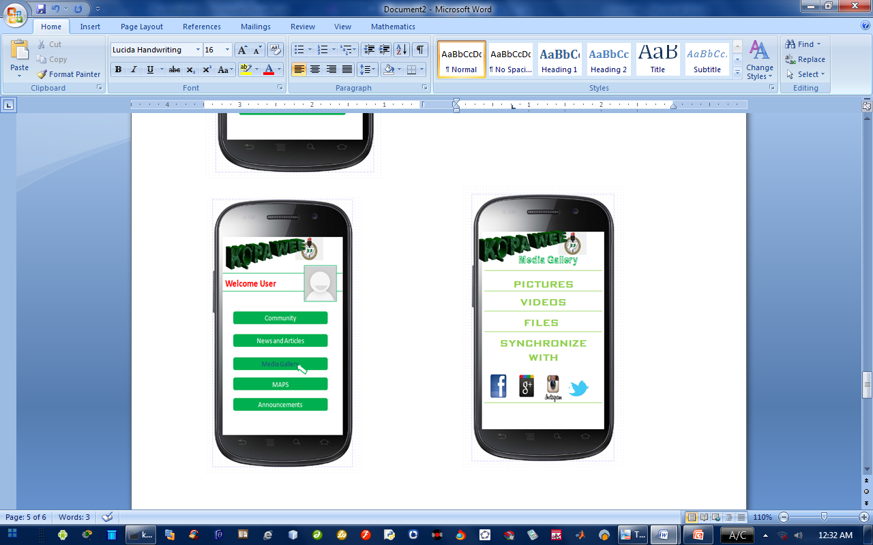

**Figure 6 The welcome screen for media gallery Figure 7 The media gallery showing activities**

The activities of the application are not totally described in this documentation but it is hoped that the contents will prove helpful in understanding the basic functionality of the system thereby understanding other important features necessary for the system’s performance.